**Lesson 1:**

This is the series of commands to navigate to the class folder and start Jupyter

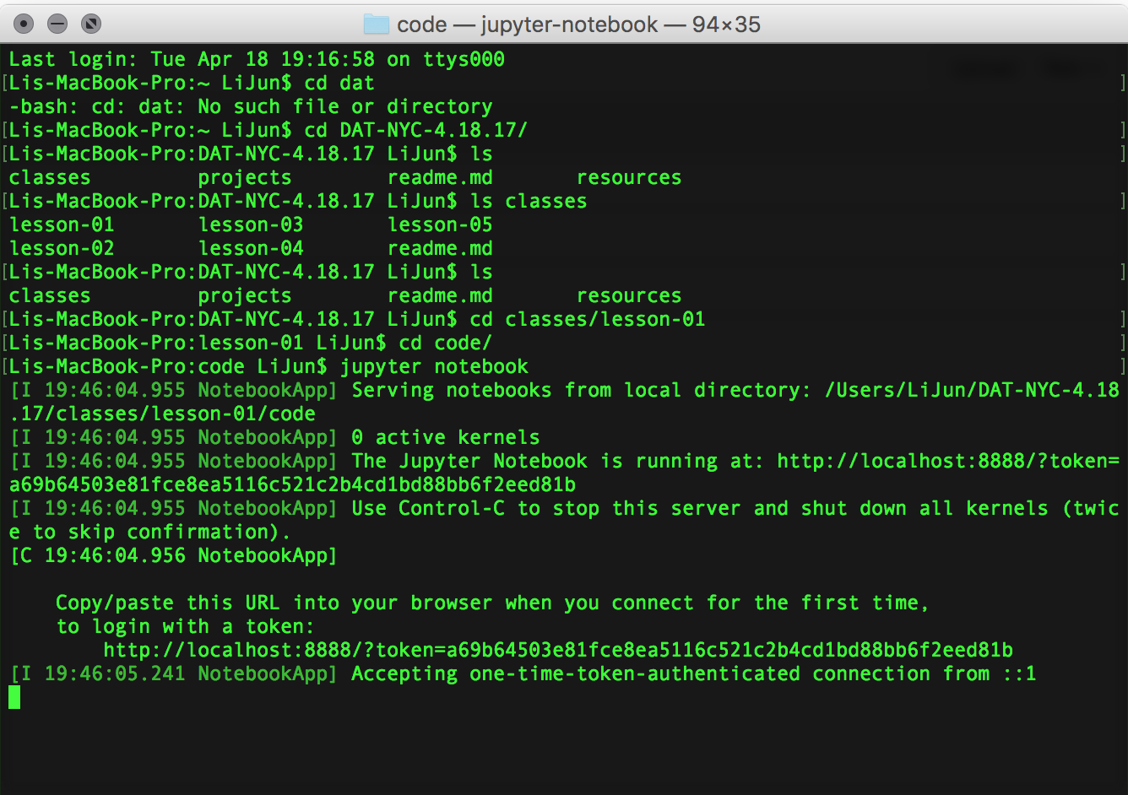

Go to Jupyter in the browser and click on “install-text” file. Run all of the program lines. The “gensim” module does not come with Anaconda so it will not run.

This is the process to add, commit, and push changes to a file in github

git add filename.ext

git commit –m “text string message”

git push

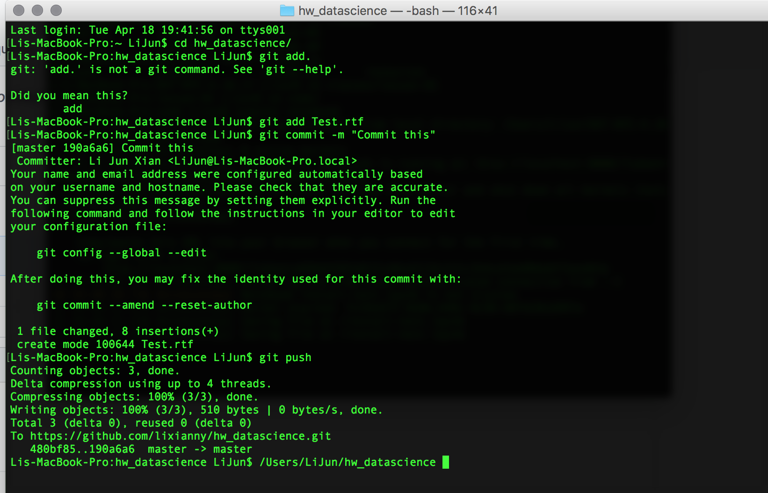

Jupyter notebooks 🡪 importing various modules (pandas) and display parameters

%matplotlib inline

import matplotlib.pyplot as plt

import matplotlib as mpl

import pandas as pd

mpl.rcParams['figure.figsize'] = (15, 6)

pd.set_option('display.width', 4000)

pd.set_option('display.max_columns', 100)

How to read a data .csv file

RangeIndex: 111069 entries, 0 to 111068

🡪 means there are 111,069 rows

noise_complaints.set_index('Created Date').info

🡪 this command using the .set_index(‘….’).**info**

[gives you a long list of the data]